KINGDOM OF SAUDI ARABIA, JAZAN UNIVERSITY

**BUSINESS COLLEGE**

**ASSIGNMENT**

|  |  |  |  |
| --- | --- | --- | --- |
| Academic Year | 2023-24 | Semester | Trimester |
| Course | IT Skills | Course Code | MGIS 271 |
| Group |  | Marks | 10 |
| **Date of Announcement** | **21.3.24** | **Deadline** | **28.3.24** |

**Instructions:**

1. Download the file and submit either as a Word or as a PDF document.
2. Assignments must be submitted through Blackboard.
3. Late submission will not be accepted.

Answer the following questions:

1. Discuss any 4 types of communication lines with picture. 2 Marks
2. List factors that affect the performance of a computer. 2 Marks
3. Differentiate between Internet and World Wide Web. 2 Marks
4. List any 5 advantages and 5 physical components of Computer Network. 2 Marks
5. What is an operating system? List any four functions of OS. 2 Marks

Q1- answer: Here are four types of communication lines commonly used:

1. Wired Communication Line

Wired communication lines use physical cables to transmit data signals. These cables can be made of copper wire, fiber optic strands, or coaxial cables. Wired communication lines offer high-speed and reliable data transmission. Here's an example of a wired communication line:

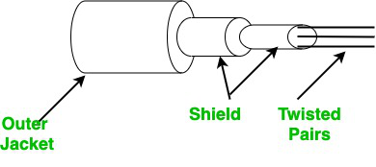

1. Wireless Communication Lines:

Wireless communication lines transmit data without the need for physical cables. They use electromagnetic waves to carry signals through the air. Wireless communication lines provide flexibility and mobility. Here's an example of a wireless communication line:

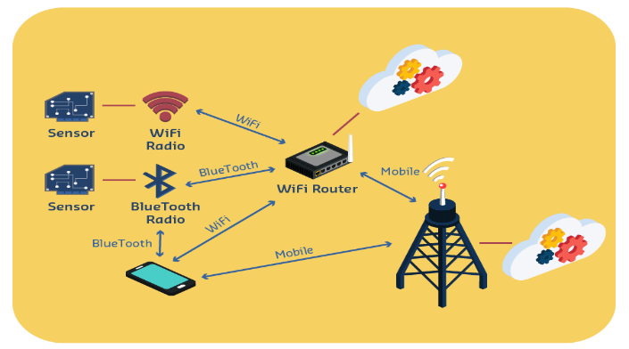

1. Satellite Communication Lines:

Satellite communication lines use satellites in orbit around the Earth to transmit data signals over long distances. They are commonly used for long-range communication, such as television broadcasting and global internet connectivity. Here's an example of a satellite communication line:

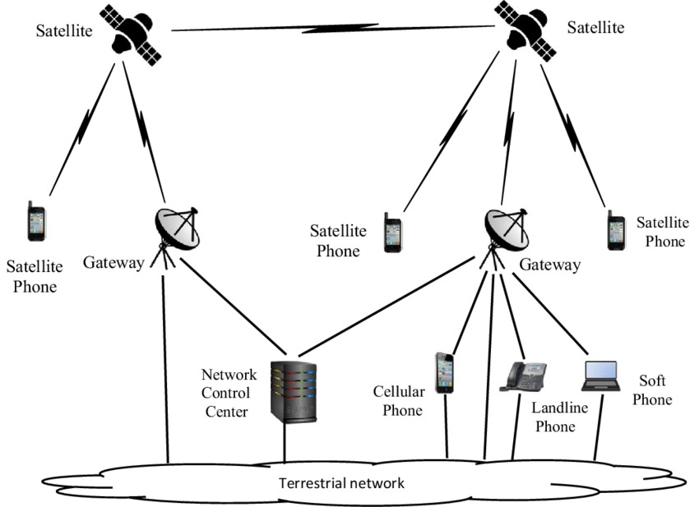

1. Optical Fiber Communication Lines:  
   Optical fiber communication lines use thin strands of glass or plastic fibers to transmit data as pulses of light. They offer high-speed data transmission over long distances and are widely used in telecommunications and internet connectivity. Here's an example of an optical fiber communication line:

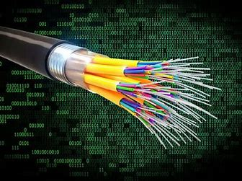

Q2- answer: There are several factors that can affect the performance of a computer. Here are some of the key factors:

* Processor (CPU): The performance of a computer is heavily influenced by the speed and capabilities of the central processing unit (CPU). A faster and more powerful CPU can handle more complex tasks and execute instructions more quickly.
* Memory (RAM): Random Access Memory (RAM) plays a critical role in computer performance. Sufficient RAM allows the computer to store and access data quickly, improving overall system responsiveness. Insufficient RAM can lead to slowdowns and bottlenecks when running memory-intensive applications or multitasking.
* Storage: The type and speed of storage devices, such as hard disk drives (HDDs) or solid-state drives (SSDs), affect how quickly data can be read from or written to the computer. SSDs are generally faster than traditional HDDs and can significantly improve system performance by reducing data access times.
* Graphics Processing Unit (GPU): GPUs are essential for tasks that require heavy graphical processing, such as gaming, video editing, or 3D modeling. A powerful GPU can enhance the performance of these applications by offloading graphics-related computations from the CPU.
* System Architecture: The overall design and architecture of a computer system can impact performance. Factors such as the motherboard, bus speed, and chipset influence how efficiently components communicate with each other.
* Operating System: The efficiency and optimization of the operating system can affect overall computer performance. Well-tuned operating systems can efficiently manage system resources, schedule tasks, and minimize unnecessary background processes, resulting in improved performance.
* Software Optimization: The performance of software applications can vary based on how well they are optimized. Well-optimized software takes advantage of hardware capabilities, minimizes resource usage, and avoids unnecessary computations, resulting in faster and more efficient execution.
* Cooling and Thermal Management: Overheating can lead to performance degradation or even system instability. Proper cooling mechanisms, such as fans or liquid cooling systems, ensure that components operate within their optimal temperature range, thereby maintaining consistent performance.
* Malware and Background Processes: Malicious software (malware) or resource-intensive background processes can consume system resources and slow down the computer. Regularly scanning for malware and managing unnecessary background processes can help maintain optimal performance.
* Upgrades and Maintenance: Regular hardware upgrades, such as increasing RAM or replacing outdated components, can enhance computer performance. Additionally, performing routine maintenance tasks like disk defragmentation, software updates, and removing unnecessary files can help optimize performance.

Q3- answer: Here's a differentiation between the Internet and the World Wide Web:

**Internet:**

* Definition: The Internet is a global network of interconnected networks that allows communication and data transfer between millions of computers worldwide.
* Infrastructure: It is a network infrastructure that consists of physical connections, routers, servers, and other networking devices.
* Communication: The Internet enables various forms of communication, such as email, instant messaging, video conferencing, and file sharing.
* Protocol: It uses protocols like TCP/IP (Transmission Control Protocol/Internet Protocol) for data transmission and routing across networks.
* Services: The Internet provides a wide range of services beyond the World Wide Web, including email, FTP (File Transfer Protocol), VoIP (Voice over Internet Protocol), online gaming, and more.

**World Wide Web (WWW):**

* Definition: The World Wide Web, often referred to as the Web, is a system of interconnected documents and resources that are accessed over the Internet.
* Content: It consists of webpages, websites, multimedia content, and other resources hosted on servers globally.
* Access and Navigation: The Web is accessed and navigated using web browsers, which interpret HTML (Hypertext Markup Language) and display webpages with text, images, links, and other media.
* Hyperlinks: The Web is characterized by hyperlinks, which allow users to navigate between webpages and access related information with a simple click.
* Protocol: The primary protocol used on the Web is HTTP (Hypertext Transfer Protocol), which facilitates the retrieval and display of web content.
* Services: The World Wide Web provides various online services and platforms, including websites, web applications, online shopping, social media, search engines, and more.

In summary, the Internet is the underlying global network infrastructure that enables communication and data transfer, while the World Wide Web is a system of interconnected webpages and resources accessed over the Internet, primarily using web browsers and HTTP. The Internet encompasses a broader range of services beyond the Web, while the Web focuses specifically on accessing and navigating web content.

Q2- answer :

**Advantages of Computer Networks:**

* Resource Sharing: Computer networks allow for the sharing of hardware devices, software applications, and data resources among connected computers. This enables cost savings, improved efficiency, and collaborative work.
* Communication and Collaboration: Networks facilitate communication and collaboration among users, allowing them to share information, exchange messages, and work together on projects in real-time. This leads to increased productivity and teamwork.
* Data Centralization and Backup: Networks enable centralized storage of data, where important files and information can be stored on dedicated servers. This allows for easier data backup, recovery, and ensures data integrity and availability.
* Improved Performance and Scalability: Networked systems can distribute computational tasks across multiple computers, enhancing overall performance. Additionally, networks can be easily scaled by adding more devices, allowing for expansion and accommodating growing business needs.
* Internet Access and Information Sharing: Computer networks provide access to the Internet, enabling users to browse websites, access online resources, and share information globally. This opens up vast opportunities for research, learning, and staying connected.

**Physical Components of a Computer Network:**

* Network Cables: Physical cables, such as Ethernet cables or fiber optic cables, are used to connect devices within a network. These cables carry data signals between computers, switches, routers, and other network components.
* Network Switches: Switches connect multiple devices within a network, allowing them to communicate with each other. They facilitate the flow of data by directing traffic to the appropriate destination based on MAC (Media Access Control) addresses.
* Network Routers: Routers are responsible for directing network traffic between different networks or subnets. They analyze IP (Internet Protocol) addresses and make decisions on how to forward data packets across networks.
* Network Servers: Servers are powerful computers that store and process data, provide services, and manage network resources. They can include file servers, web servers, email servers, database servers, and more, depending on the network requirements.
* Network Interface Cards (NICs): NICs are hardware components that allow computers to connect to a network. They provide the physical interface between a computer and the network medium, such as Ethernet or Wi-Fi, enabling data transmission and reception.

Q5- answer:

An operating system (OS) is a software program that acts as an intermediary between computer hardware and software applications. It manages and controls the hardware resources of a computer system, provides a user interface, and facilitates the execution of software programs. Here are four key functions of an operating system:

* Process Management: The OS manages and oversees the execution of processes (programs) on the computer system. It allocates system resources, such as CPU time, memory, and input/output (I/O) devices, to different processes, ensuring efficient utilization and fair sharing of resources. The OS also handles process scheduling, synchronization, and communication between processes.
* Memory Management: The OS is responsible for managing the computer's memory resources. It allocates and deallocates memory space to processes as needed, ensuring efficient memory utilization. It also handles virtual memory management, which allows programs to use more memory than physically available by utilizing disk space as an extension of main memory.
* File System Management: The OS provides a file system that organizes and manages files stored on storage devices such as hard drives or solid-state drives. It handles file creation, deletion, and manipulation operations. The OS also manages file access permissions, ensuring data security and facilitating efficient retrieval and storage of data.
* Device Management: The OS controls and manages input/output devices (e.g., keyboards, mice, printers, disk drives) connected to the computer system. It handles device drivers, which are software components that enable communication between the OS and the hardware devices. The OS coordinates device access, handles input/output requests from applications, and ensures efficient and reliable device operation..